

School of mechanical and manufacturing engineering

**Laboratory 2: Measurement of Sound Power Levels by The Direct and The Comparison Methods**

Name: Hengcheng Zhang

Student ID: z5130844

# 1. Introducion:

The aim of the second laboratory session is to measure the sound power level of a noise source, which is an electric drill located hard surface of a semi-reverberant field. Two methods were used to correct the reverberation effects: the direct method and the comparison method. The whole experiment procedure followed the instruction of Australian Standard AS 1217.5. AS 1217 is a series of standards which set out various of methods to determine the sound power levels of machines and equipment. These documents specify the measuring requirements for different test environment. Among them, AS1217.5 is specified for the environment of outdoor or in large room, which is suitable for this experiment.

# 2. Apparatus:

The equipment used in this laboratory session is listed below.

## 2.1 Sound Level Meter (SLM): *Brüel & Kjær* Type 2250

The B&K 2250 is a compact hand-held sound level meter, which is mounted with a free field microphone on the top. It contains a preamplifier which transfers sound pressure into voltage. It has a broadband filter range from 3 Hz to 20KHz. This sound level meter is a powerful sound recorder and analyser. It is able to demonstrate the sound Level, spectrum plot and other kinds of sound parameters.

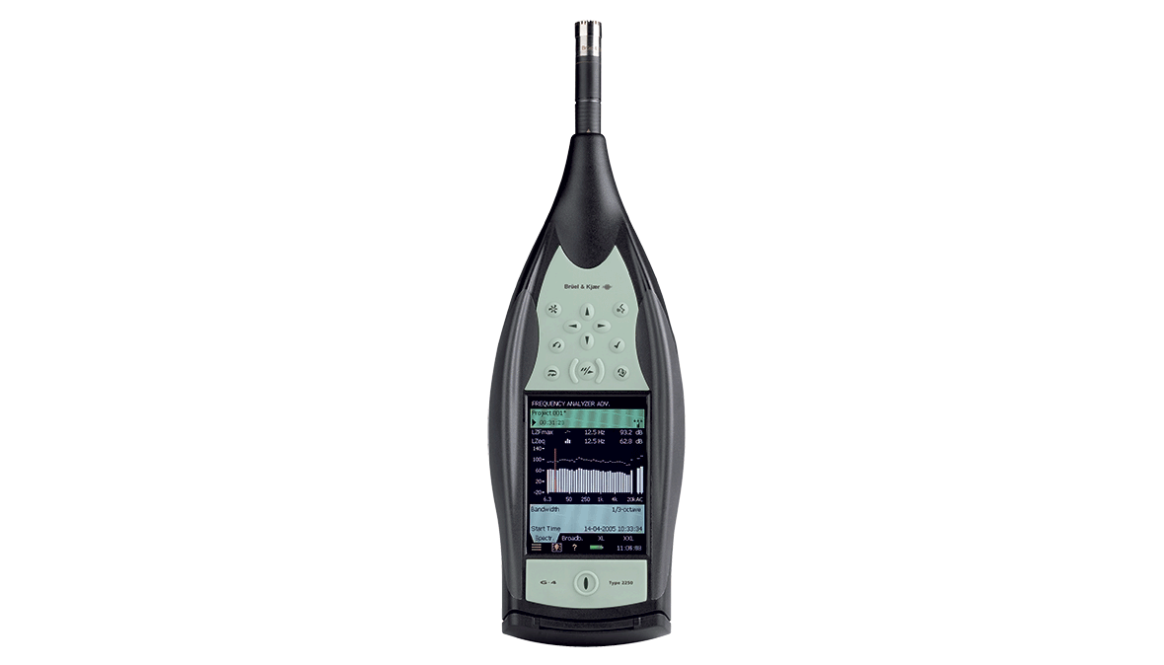

*Figure 1: B&K Type 2250 Sound Level Meter*

## 2.2 Microphone

The 4189 free-field microphone is a high-precision, high-sensitivity general purpose microphone. It is able to capture sound of frequency range from 6.3 Hz to 20k Hz with a dynamic range of 14.6 to 146 dB.

## 

*Figure 2: B&K Type 4189 Free-field Microphone*

## 2.3 Sound Level Calibrator: *Brüel & Kjær* Type 4231

The sound level calibrator generates a sound of 94 dB sound pressure level at 1000Hz when turned on. This stable sound is used to calibrate the SLM. The calibration process is easy to execute, which is shown below in the procedure part.

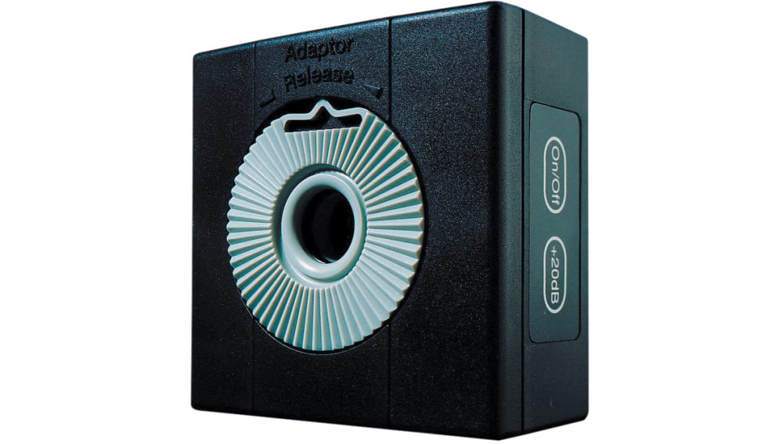

*Figure 3: B&K Type 4231 Sound Level Calibrator*

## 2.4 Makita electrical drill

This normal electrical drill was used as the noise source in this experiment

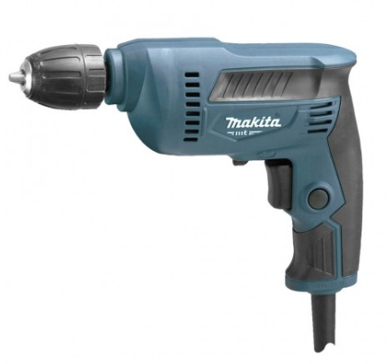

*Figure 4: Makita electrical drill*

## 2.4 B&K Reference Sound Source Type 4204

This instrument is used in the comparison method. It has been located next to the drill from the beginning while the drill was operated, is switched on and octave band sound pressure level measurements are made at the same ten locations (the drill is switched off).



*Figure 5 Reference Sound Source Type 4204*

# 3. Procedure:

As discussed in the former part, two measurement methods are performed in this experiment, the comparison method and the direct method. Both methods should follow the instruction of Australian standard AS 1217.5. So, before taking measurement, the experiment environment should be initially set up according to the standard.

## 3.1 Initial Setup

AS 1217.5 specified how this experiment is taken, including the test environment setting, the test instrumentation, operation of the source and the measurement procedure. This particular experiment is performed in a large room, which is suitable for this standard. The test locations are set up as instructed, which is a hemispherical surface and is shown below in figure 6 and table 1.

Table 1: Coordinates of Key Measurement Points

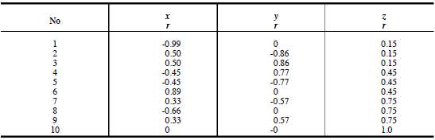

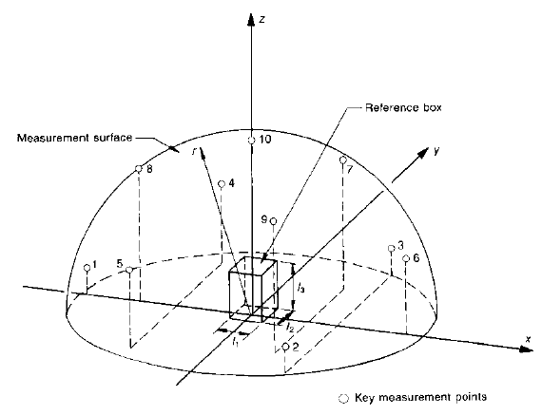

*Figure 6: Hemispherical measurement surface*

## 3.2 Calibration

In order to make sure of the accuracy of measurement result, calibration is always the first step of taking use of the sound level meter.

External calibration is utilized with a help of the 4231 calibrator in this experiment. The first step is to switch on the calibrator and the SLM, make sure the calibrator is producing sound. Then attach it to the top of the sound level meter, where the microphone is located. The next step is to click calibrate option on the screen. When this calibration is finished, remove and turn off the calibrator. The sound level shown on the screen should be 94 dB.

## 3.3 Measurement of Reference Sound Source

The measurement layout is shown in figure 6 and table 1. The positions are marked by white tape on the laboratory floor around the noise source.

In this section, the B&K reference noise source was placed at the centre of the measurement hemisphere, which is shown as reference box in figure 6.

Then turn on the reference source and start to take measurement at each of the 10 positions. During the measurement, a wooden ruler is used to carry out the height of the SLM at each position according to the configuration. The examiner should hold the sound level meter as far as possible away from human body, and aim the microphone at the sound source. At each point, it should take a record no less than 30 seconds to generate the measurement results.

Record the amplitude of frequencies of 125, 250, 500, 1000, 2000 and 3150 Hz after each measurement of each position. The data needs not to be stored in the SLM, and was discarded after each test. The results are shown in table 2.

## 3.4 Measurement of Electrical Drill

In this part of measurement, the B&K 4204 reference source was turned off and replaced with the Makita electric drill. The measurement procedures are basically the same with the comparison method. The positions are also of no difference.

Record the amplitude of 125, 250, 500, 1000, 2000 and 3150 Hz frequencies of each point. The data is shown in table 3.

After all, the drill should be turned off and each device was replaced.

# 4. Results and discussion

The sound pressure level of each point at each frequency for the reference sound source is tabulated below in Table 2.

*Table 2: Experiment Data of Drill*

|  |  |  |  |  |  |  |  |  |  |  |
| --- | --- | --- | --- | --- | --- | --- | --- | --- | --- | --- |
| Frequencies [Hz] | 1 [dB(A)] | 2 [dB(A)] | 3 [dB(A)] | 4 [dB(A)] | 5 [dB(A)] | 6 [dB(A)] | 7 [dB(A)] | 8 [dB(A)] | 9 [dB(A)] | 10 [dB(A)] |
| 125 | 33.9 | 38.9 | 39 | 36.5 | 36.5 | 37.4 | 34.1 | 34.8 | 39.6 | 29.5 |
| 250 | 32.9 | 33.3 | 36.4 | 35 | 30.9 | 32.5 | 32.7 | 32 | 31.8 | 31.8 |
| 500 | 38.3 | 40.1 | 39 | 38.2 | 40.3 | 36.2 | 39.1 | 36.9 | 36 | 37.1 |
| 1000 | 42 | 49.6 | 47.4 | 47.8 | 48 | 44.2 | 46.4 | 46.9 | 45 | 44.8 |
| 2000 | 59.8 | 57.7 | 59.9 | 59.6 | 58.3 | 55.9 | 56.2 | 56.4 | 56.3 | 55.7 |
| 3150 | 54.5 | 55.5 | 55.1 | 54.8 | 55.6 | 53.4 | 52.2 | 52.9 | 53.7 | 52.3 |

Similarly, the sound pressure levels recorded for the electrical drill in each individual point across different octave frequency band are recorded below in Table 3.

*Table 3: Experiment Data of Reference Sound Source*

|  |  |  |  |  |  |  |  |  |  |  |
| --- | --- | --- | --- | --- | --- | --- | --- | --- | --- | --- |
| Frequencies [Hz] | 1 [dB(A)] | 2 [dB(A)] | 3 [dB(A)] | 4 [dB(A)] | 5 [dB(A)] | 6 [dB(A)] | 7 [dB(A)] | 8 [dB(A)] | 9 [dB(A)] | 10 [dB(A)] |
| 125 | 33.9 | 38.9 | 39 | 36.5 | 36.5 | 37.4 | 34.1 | 34.8 | 39.6 | 29.5 |
| 250 | 32.9 | 33.3 | 36.4 | 35 | 30.9 | 32.5 | 32.7 | 32 | 31.8 | 31.8 |
| 500 | 38.3 | 40.1 | 39 | 38.2 | 40.3 | 36.2 | 39.1 | 36.9 | 36 | 37.1 |
| 1000 | 42 | 49.6 | 47.4 | 47.8 | 48 | 44.2 | 46.4 | 46.9 | 45 | 44.8 |
| 2000 | 59.8 | 57.7 | 59.9 | 59.6 | 58.3 | 55.9 | 56.2 | 56.4 | 56.3 | 55.7 |
| 3150 | 54.5 | 55.5 | 55.1 | 54.8 | 55.6 | 53.4 | 52.2 | 52.9 | 53.7 | 52.3 |

## 4.1 The Direct Method

### 4.1.1 Calculation of Averaged Sound Pressure level

The first step is to calculate the sound pressure level $\overline{L_{pm}}$ averaged over the measurement surface for each octave band. The equation is as following:

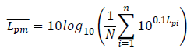

Taking 125 Hz for example, the average measured sound pressure level can be calculated as:

$\overline{L_{pm}}=10Log\left[\frac{1}{10}\left({10}^{3.39}+{10}^{3.89}+{10}^{3.9}+{10}^{3.65}+{10}^{3.65}+{10}^{3.74}+{10}^{3.41}+{10}^{3.48}+{10}^{3.96}+{10}^{2.95}\right)\right]=36.83 dB(A)$

Calculate average sound pressure level for the other frequencies in the same way. The results are shown in Table 4.

### 4.1.2 Calculation of Surface Sound Pressure Level

The second step is to calculate the surface sound pressure level. The surface sound pressure level $\overline{L_{pf}}$ is obtained by correcting the average sound pressure level $\overline{L_{pm}}$ by the environment correction factor, $K$.

$$\overline{L_{pf}}= \overline{L_{pm}}-K$$

The environment correction factor $K$ is given by:

$$K=10log⁡(1+\frac{4}{A/S} )$$

Where, ***S*** is the area of the enclosing hemispherical surface. The radius of the hemisphere is 1 m, so, ***S*** = 6.28 m2.

A is the equivalent sound absorption area. The calculation method of A is as instructed in Australia standard AS 1045:

$$A= \frac{55.3*V}{c*T_{60}}$$

Where:

* V is the volume of the reverberant room, which is given as 528 m3.
* c is the velocity of sound in air. Here take the 20 °C value 343 m/s into this equation.
* T60 is the reverberation time, which is defined as the time it takes for the sound pressure to reduce by 60 dB. The T60 values are not given in this project. Alternatively, the values of T10, T20 and T30 are given out, which are demonstrated in the following table. T60 is then carried out by linear regression along the T10, T20 and T30 values of each frequency. Calculation results of T60 are also listed in the same table.

*Table 4: Reverberation Time*

|  |  |  |  |  |  |  |
| --- | --- | --- | --- | --- | --- | --- |
| Frequency [Hz] | 125 | 250 | 500 | 1000 | 2000 | 3150 |
| T10 [s] | 1.14 | 1.81 | 1.73 | 2.05 | 2.1 | 1.63 |
| T20 [s] | 1.21 | 1.77 | 1.96 | 2.39 | 2.14 | 1.87 |
| T30 [s] | 1.25 | 1.6 | 2.01 | 2.9 | 2.13 | 1.9 |
| T60 [s] | 1.42 | 1.31 | 2.46 | 2.98 | 2.18 | 2.34 |

Now, it is able to derive the equivalent sound absorption area ***A*** and environment correction factor ***K***. It should be noticed that, as instructed by AS 1217.5, the maximum allowable range of the environment correction factor ***K*** is -2 dB to +10 dB for indoors highly reverberant rooms. The results are within this range. Furthermore, the surface sound pressure levels $\overline{L_{pf}}$ could be calculated. The results are shown below in Table 5

*Table 5: Calculation Results of Surface Sound Pressure Level*

|  |  |  |  |  |  |
| --- | --- | --- | --- | --- | --- |
| Frequency [Hz] | T60 [s] | A [m^2] | K [dB(A)] | L_pm [dB(A)] | L_pf [dB(A)] |
| 125 | 1.42 | 59.95 | 1.52 | 36.83 | 35.31 |
| 250 | 1.31 | 65.15 | 1.42 | 33.24 | 31.83 |
| 500 | 2.46 | 34.60 | 2.37 | 38.36 | 35.99 |
| 1000 | 2.98 | 28.57 | 2.74 | 46.68 | 43.94 |
| 2000 | 2.18 | 38.99 | 2.16 | 57.89 | 55.73 |
| 3150 | 2.34 | 36.38 | 2.28 | 54.17 | 51.89 |

### 4.1.3 Calculation of Sound Power Level

The final step is to calculate the sound power level, ***LW***. The sound power level is used to characterize the noise emitted by the source. It shall be calculated from the following equation:

$$L_{w}= \overline{L_{pf}}+10log⁡(\frac{S}{S_{0}})$$

Where:

* S is the area of measurement surface, which is 6.28 m2 as same as shown in 4.1.2.
* S0 is the reference area, which is given as 1 m2

This allows us to carry out the power levels of the noise source, which is displayed below in Table 6.

*Table 6: Calculation of Sound Power Level*

|  |  |  |
| --- | --- | --- |
| Frequency [Hz] | L_pf [dB(A)] | L_w [dB(A)] |
| 125 | 35.31 | 43.29 |
| 250 | 31.83 | 39.81 |
| 500 | 35.99 | 43.97 |
| 1000 | 43.94 | 51.92 |
| 2000 | 55.73 | 63.71 |
| 3150 | 51.89 | 59.86 |

## 4.2 The Comparison Method

The comparison method needs to utilize a reference sound source whose sound power is already known. It is B&K 4202 in this project, and its test data is shown in Table 3. The difference of direct method and the comparison method is calculation of environment correction factor ***K***. So the first step is set to the calculation of ***K***.

### 4.2.1 Calculation of Environment Correction Factor

The environment correction factor should be derived from the reference sound source in comparison method. The equation is given by:

$$K= L_{Wr\left(uncorrected\right)}- L_{Wr}$$

Where:

* $L_{Wr\left(uncorrected\right)}$ is the uncorrected sound power level of the reference source.
* $L_{Wr}$ is sound power level of the reference sound source.

The sound power level of the reference sound source $L_{Wr}$ is given by the product datasheet. It should be noticed that the raw data is given as weighted value. A-weighting process must be performed first. This procedure and results are shown in Table 7.

*Table 7: A-weighting of Reference Sound Power Level*

|  |  |  |  |
| --- | --- | --- | --- |
| Frequency [Hz] | L_w,ref,unweighted [dB] | A-Weighting [dB(A)] | L_w,r  [dB(A)] |
| 125 | 75.50 | -16.10 | 59.40 |
| 250 | 77.70 | -8.60 | 69.10 |
| 500 | 77.90 | -3.20 | 74.70 |
| 1000 | 82.10 | 0.00 | 82.10 |
| 2000 | 82.40 | 1.20 | 83.60 |
| 3150 | 79.60 | 1.20 | 80.80 |

The uncorrected sound power level of the reference source $L_{Wr\left(uncorrected\right)}$ could be calculated using the formula:

$$L_{Wr\left(uncorrected\right)}= \overline{L_{pm}}+10log⁡(\frac{S}{S_{0}})$$

$\overline{L_{pm}}$ is the sound pressure level averaged over the measurement surface. It is calculated by the same procedure as in the direct method from data in Table 3. S and S0 are also the same as in direct method, namely S = 6.28 m2 while S0 = 1 m2. The results are shown in Table 8 below.

The environment correction factor K could then be calculated with the values of $L_{Wr\left(uncorrected\right)}$ and $L_{Wr}$. The results are also shown below in Table 8.

*Table 8 Calculation of uncorrected sound power level and the environment correction factor*

|  |  |  |  |  |
| --- | --- | --- | --- | --- |
| Frequencies [Hz] | L_pm [dB(A)] | L_w,r,uncorrected [dB(A)] | L_w,r [dB(A)] | K [dB(A)] |
| 125 | 51.58 | 59.56 | 59.40 | 0.16 |
| 250 | 60.09 | 68.07 | 69.10 | -1.03 |
| 500 | 65.04 | 73.02 | 74.70 | -1.68 |
| 1000 | 73.81 | 81.79 | 82.10 | -0.31 |
| 2000 | 75.74 | 83.72 | 83.60 | 0.12 |
| 3150 | 72.24 | 80.22 | 80.80 | -0.58 |

### 4.2.2 Calculation of the Sound Power Level

The following steps are almost the same as in the direct method. The sound power level of the drill could be given by the following formula:

$$L_{w}= \overline{L_{pf}}+10log⁡(\frac{S}{S_{0}})$$

Where S = 6.28 m2 and S0 = 1 m2.

The surface sound pressure level of the drill $\overline{L_{pf}}$ is given by:

$$\overline{L_{pf}}= \overline{L_{pm}}-K$$

The results are shown below in Table 9.

*Table 9: Calculation of Sound Power Level of Drill*

|  |  |  |  |  |
| --- | --- | --- | --- | --- |
| Frequencies [Hz] | K [dB(A)] | L_pm [dB(A)] | L_pf [dB(A)] | L_w [dB(A)] |
| 125 | 0.16 | 36.83 | 36.67 | 44.65 |
| 250 | -1.03 | 33.24 | 34.28 | 42.26 |
| 500 | -1.68 | 38.36 | 40.04 | 48.02 |
| 1000 | -0.31 | 46.68 | 47.00 | 54.98 |
| 2000 | 0.12 | 57.89 | 57.76 | 65.74 |
| 3150 | -0.58 | 54.17 | 54.75 | 62.73 |

## 4.3 Discussion

Comparing the results of two methods, it could be found that the results of the comparison method are relatively higher than the values of direct method in all frequency. The highest difference shows in 500 Hz, which is 4.05 dB. The total value is calculated by the formula:



The difference of total value is 2.34 dB. The AS 1217.5 is asked to achieve an engineering grade of accuracy. These differences could be recognised as minimal and are within this accuracy grade. The direct reason for this difference is the variation of K in different method. The values of K increased to its highest value and then decreased in direct method. All the values are positive numbers in this method. While in comparison method, the values of K decreased to negative values first, and then recovered to values around zero.

*Table 10: Comparison of Direct Method with Comparison Method*

|  |  |  |  |
| --- | --- | --- | --- |
| Frequency [Hz] | L_w(d) [dB(A)] | L_w(c) [dB(A)] | del_Lw [dB(A)] |
| 125 | 43.29 | 44.65 | 1.36 |
| 250 | 39.81 | 42.26 | 2.45 |
| 500 | 43.97 | 48.02 | 4.05 |
| 1000 | 51.92 | 54.98 | 3.05 |
| 2000 | 63.71 | 65.74 | 2.04 |
| 3150 | 59.86 | 62.73 | 2.86 |
| Total | 65.48 | 67.82 | 2.34 |

The differences of sound power level in the two methods are also illustrated in the figure below, which could be more intuitional.

*Figure 7: Comparative Plot of Direct Method and Comparison Method*

# 5. Conclusion